GRANARD MUNICIPAL DISTRICT

Corporate Affairs,
Aras an Chontae,
LONGFOIRT.

17th November 2015.

Please note Venue of Meeting – Drumlish Branch Library.

To: Each Member of Granard Municipal District.

Dear Member,

You are requested to attend Meeting of Granard Municipal District to be held in the Drumlish Community Library on Tuesday, 24th November 2015 at 3.00 p.m. to transact business, as set out on the Agenda hereunder.

Yours sincerely,
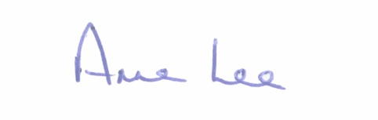

_______________
Anne Lee,
Meetings Administrator.

AGENDA

Prayer before meeting.

1. Confirmation of Minutes of the following Meetings of Granard Municipal District -

- Meeting held on the 22nd September 2015.
- Committee Meeting held on the 27th October 2015.
- copies enclosed.

2. Matters arising from Minutes.

3. Presentation on Longford Local Economic and Community Plan -
Socio-Economic Statement enclosed.

4. Consideration of the Taking in Charge of ‘St. Johns’ Housing Estate, Ballinalee, Co. Longford - details attached.

5. Notice of Motion submitted by Councillor P.J. Reilly.

“That Granard Municipal District contacts Irish Water regarding upgrading work on the Ballywillan/Creevy Granard water line and also on the Carragh/Aughnagarron water line as both these lines are causing serious problems with bursts frequently.”

6. A.O.B.

